**Suggested Reading:** High Resolution 1s Core Hole X-Ray Spectroscopy in 3d Transition Metal Complexes—Electronic and Structural Information [1]

**Vocabulary Words:**

**Decay Channel:** A path through which a quantum system such as an atom, molecule, or subatomic particle can transition from a higher energy state to a lower energy state.

**Ligand:** An ion or molecule which bonds to a central metal atom.

**Exercise:**  Fill in the blanks in the diagram below.

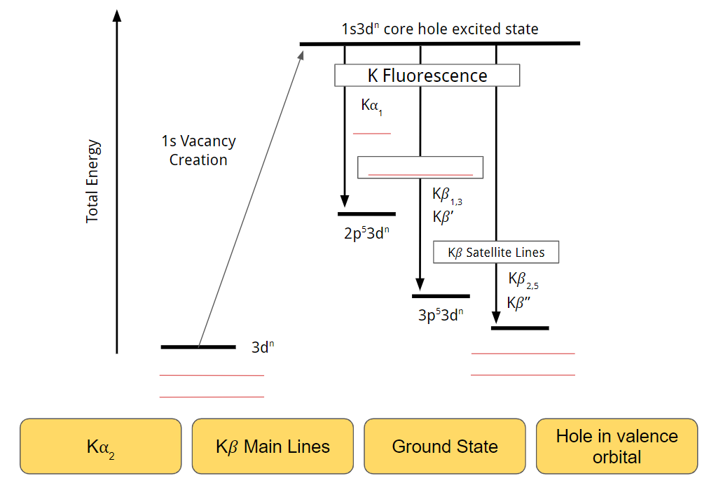

1. XES and emission basics
2. Based off the transition, write down the electron starting state and finishing state in the table below, in (n,l,j) and Siegbahn notation:

| Transition: | Electron Starting State: | Electron Ending State: |
| --- | --- | --- |
| $Kα_{1}$ | (2,1,3/2), 2p3/2 | (1,0,1/2), 1s |
| $Lβ_{1}$ |  |  |
| $Kβ_{2}$ |  |  |
| $Lγ_{1}$ |  |  |
| $Kβ_{1}$ |  |  |

1. XES is used to study the intensities of different fluorescence lines. For the K shell fluorescence lines, $Kα$ is the strongest (in terms of intensity), followed by $Kβ$ and then transitions from higher orbitals.

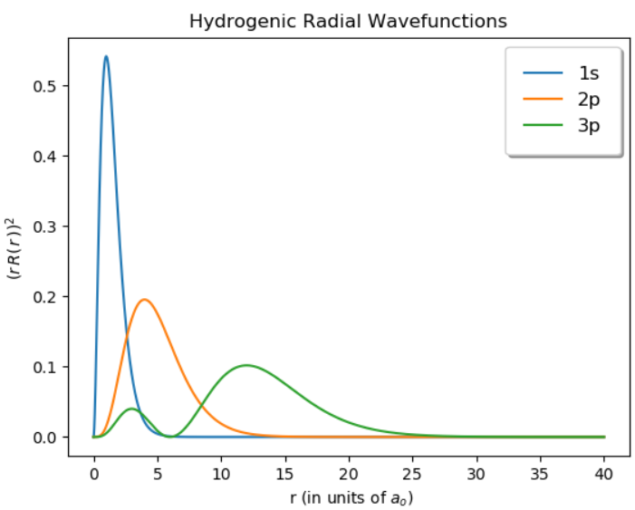

Considering the above plot, give a brief qualitative explanation of why the $Kα$ fluorescence intensity is the strongest.

It all comes down to the overlap integral. Essentially there is more overlap between the 2p and 1s wavefunctions (the two orbitals involved in the $Kα$ line) than there are for any other orbitals with the 1s.

1. What is the connection between (x-ray fluorescence) XRF spectroscopy and XES? What is the difference between the analytical applications of the two techniques?

XES is essentially very high resolution XRF. While XRF spectroscopy is primarily used for identifying elemental species and concentrations, XES is used for studying the chemical properties of the material by analyzing the fine spectral features of the fluorescence lines. Essentially the high resolution nature of XES allows it to have applications beyond just species identification.

1. If you are interested in studying local properties of an atom in a system, such as the through transitions between shells (ex: 1s2p or 1s3p), then what part of the XAFS would you usually use? Generally speaking, what is the issue with extracting information from this region of the XAFS spectrum?

Normally we would use the pre-edge features in the XAFS, which probe transitions between shells and give chemical sensitivity to the local environment. However, there is a large background in this region from the rising edge, limiting the ability to analyze spectral features using conventional absorption spectroscopy.

1. If conventional XAFS is used to study the unoccupied states by probing the energies at which absorption occurs, then in comparison what is XES used to study? Additionally, conventional XAFS is classified as an excited state spectroscopy. Is this also true of XES? Explain.

A state must be occupied for an electron to decay from it. Therefore XES studies the occupied states (of the excited system) by measuring the energies at which radiative decays occur and the features of the fluorescence lines. XES is also fundamentally an excited state spectroscopy because a core-hole must first be created for a decay to occur.

1. The XAS process is described very well in first-order approximation by Fermi’s golden rule (given below) which gives the transition probability per unit of time from the initial state *i* to a final state *f,* with *H’* being the perturbation between the final and initial states, and 𝜌(*EF*) is the density of states. The perturbation *H’* comes from the interaction of the x-ray and the electron in the initial state *i*.

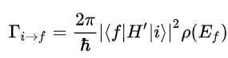

XES is very similar to XAS in that it can also be described by Fermi’s golden rule, albeit going in “the other direction”.Consider a particular K-edge x-ray absorption event, where the initial state is the 1s shell, the final state is the 2p3/2 shell, the perturbation *H’* is the dipole transition operator. How would these three components of Fermi’s golden rule change for the XES version?

The initial state and final state will be switched, initial state 2p3/2 final state 1s, otherwise known as the K⍺1 emission line. The dipole transition operator will be complex conjugated compared to the XAS version.

1. While recent technological advancements (newer optics, detectors, higher flux light sources, ect) are changing the modern day XES landscape, historically XES often required some sort of dispersive optical setup. Why is this? (Hint: Consider the difference between XRF and XES)

The FWHM of x-ray fluorescence lines are often quite small and require incredibly high energy resolution to be able to accurately distinguish spectral features. One of best ways to achieve this is through a dispersive optical setup such as a Rowland Circle with perfect-crystal Bragg optics.

1. Sensitivity
2. Explain in general terms, why the fluorescence lines would be sensitive to the local chemical environment. Why should we expect them to have any sensitivity to their environment at all?

The intensity of fluorescence is influenced by exchange interactions between the core-hole and the unpaired electrons in the valence shells. These valence electrons are related to bonding, magnetism, oxidation, and many other chemical properties of an atom. Naturally, any emission that is connected to valence electrons will be linked to the chemical environment in the vicinity of the atom.

1. Below is a diagram (adapted from ref [2]) of a simplified molecular orbital schematic for a transition metal (TM) bonded to a lighter ligand (L) element. The valence-to-core (VTC) emission lines are in blue, the $Kβ$ emission lines are in green, and the $Kα$ emission lines are in red. The Nv is just the principal quantum number of the valence state of the ligand (ex: Nv = 2 for Oxygen), which will of course vary depending on the ligand species. Based on your answer to the previous problem, explain generally what chemical properties the different emission lines might be sensitive to.

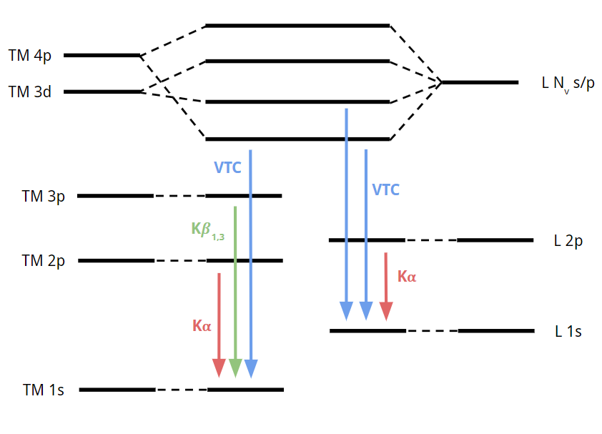

The core-to-core (2p-> 1s) K⍺ transition may be sensitive to oxidation state, as the oxidation of the transition metal by the ligand will change the screening and therefore the binding energy of the 1s core electron. However, while the K⍺ transition is the strongest of the ones shown here, it generally is the least sensitive to chemical environment because it only involves core orbitals. The K𝛽 and VTC transitions are more closely connected to the orbitals involved in bonding and therefore may provide information about ligand geometry, ligand species, oxidation states, ect.

1. Why are spectral changes (changes in intensity, FWHM, ect) more pronounced in the $Kβ$ emission lines than in the $Kα$ emission lines for transmission metals? What about for VTC transitions, how pronounced are their spectral changes compared to $Kβ$ and $Kα$?

There is more overlap between the 3p and 3d orbitals than there is for the 2p and 3d orbitals. This makes the $Kβ$ emission lines more sensitive to the local chemical environment and therefore changes in the spectral features are more distinct than in the $Kα$ emission lines. While $Kα$ may be chemically sensitive in *some* materials, as a general rule $Kβ$ is more chemically sensitive and across a broader range of systems. The VTC case is only a more extreme version of the relationship between $Kβ$ and $Kα$ emission lines. In general we can conclude that the more weakly bound the initial state of the XES transition is, the more sensitive it is to the chemical environment.

Citations:

[1] Glatzel, Pieter, and Uwe Bergmann. “High Resolution 1s Core Hole X-Ray Spectroscopy in 3d Transition Metal Complexes—Electronic and Structural Information.” *Coordination Chemistry Reviews*, vol. 249, no. 1-2, 2005, pp. 65–95., doi:10.1016/j.ccr.2004.04.011.

[2] Pollock, C.J. and S. DeBeer, *Valence-to-Core X-ray Emission Spectroscopy: A Sensitive Probe of the Nature of a Bound Ligand.* Journal of the American Chemical Society, 2011. 133(14): p. 5594-5601.